Experiment:LDR(night lamp)

* CIRCUIT DIAGRAM: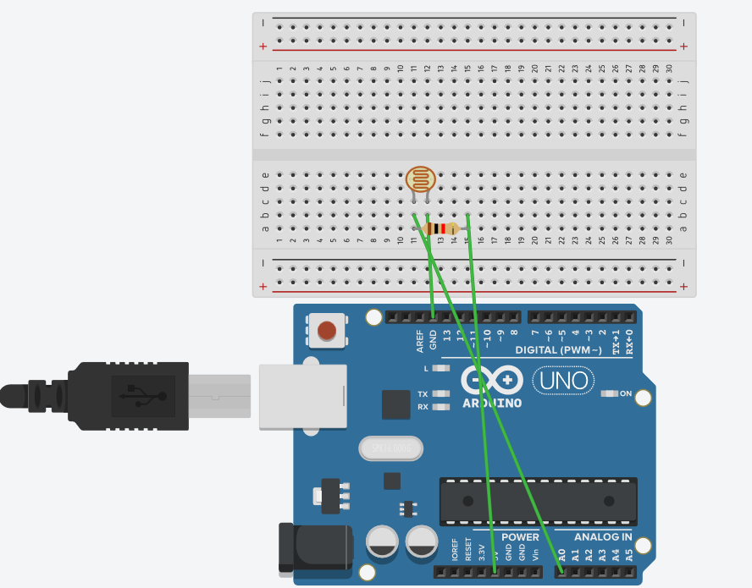
* THEORY:

CONCEPT USED:

The concepts used for realization and implementation of the task are:

1)LDR (Light Dependent Resistor) is a light controlled variable resistor. The resistance of a photoresistor decreases with increasing incident light intensity.

2)A photoresistor is made of a high resistance semiconductor.

3)Working principle of LDR is photo conductivity.

4)This concept can be used for a night lamp.

LEARNING AND OBSERVATIONS:

1)I learned the concept of LDR and how the connections can be made with the help of breadboard and Arduino.

2)I learned about relation between light intensity and resistance.

3)I observed, after connecting the port there were variations in the value of resistances when the light intensity was high or low.

PROBLEMS AND TROUBLESHOOTING:

1)The circuit was not getting completed at times due to short wires so I tried to change the wires and manage the connections somehow.

2)Selection of wrong port could not upload the Arduino code so correcting that helped out.

3)Lack of practice can be considered as a problem too. Practicing more can act as a troubleshoot to this.

PRECAUTIONS:

1)One can make circuit diagram before making the connections on breadboard.

2)We should take care that the circuit is closed

3)Arduino code written should be correct and selection of port and tools should be kept in mind.

LEARNING OUTCOMES:

1)I have gained knowledge about LDR and how connections can be made on breadboard and Arduino.

2)I have also learned the concept of night lamp and about some related projects too.